Week 5 Visualizations Assignment_Star Wars (ANA515 SU22)(Andrew Cutchin)

Andrew Cutchin

2022-06-25

This scatterplot shows the mapping of Age on the x-axis, Education for the y-axis, and color indicates the Gender of the respondent. The scale of the x-axis had to be altered to go youngest to oldest, from left to right. The y-axis was reordered to show increasing level of education when moving upwards.

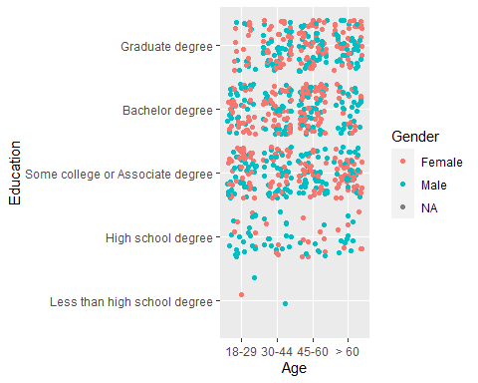

This bar chart shows the count of the ranking by each respondent of the Star Wars movie, Episode 1:The Phantom Menace. The x-axis shows the ranking 1-6, 1 being the highest and 6 being the lowest. Each repondent was supposed to rate each of the six films by numbering them from 1-6. All respondents that did not rate this film in there responses were removed. The y-axis shows the count of each rating among respondents. Each count is broken up into age groups of the respondent whom made that particular rating.

